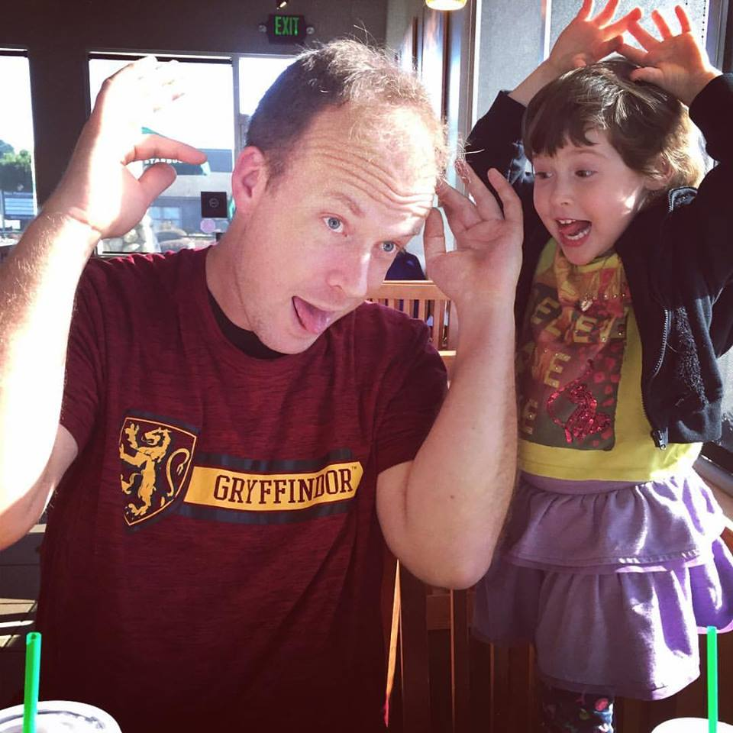

Task: what are you doing? Was it a discrete, serial, or continuous task? (Describe)
I was raising my arms, tilting my head, and sticking my tongue out to entertain my girlfriend’s daughter from her previous relationship. This was a discrete task, because even though multiple movements occurred, they were all done at the exact same moment, and had a concrete start point and concrete end point.
Environment: what was the environment like? Was it an open or closed environment? (Describe)
It was a quasi-intermediate between open and closed. People usually go to Starbucks to use the internet, read, drink coffee, and talk, which makes it a closed environment. Anyone, and anything, could have happened inside the building at the exact moment the three of us were there, which makes it an open environment. During business hours when the Starbucks is open, it is an open environment where anyone could walk through the door or anything could happen.
Person: who are you? What sensory information were you using (vision, touch, hearing)? What were you thinking about? How were you physically moving your body?
Gryphon, and I was using vision to see that her daughter could use some entertainment, touch for picking up frap to drink it, hearing to hear girlfriend’s laugh and her daughter’s and I’s “ehhhh” random noise we made.
Dr. Ogle,
I do not take a lot of pictures of myself, and I do not have a lot of pictures taken of me. I have anxiety and self-image/self-esteem issues. I only have a Facebook account open for communication with HSU Archery program, and if I was not in Archery I would close my FB account. I don’t usually enjoy taking pictures, and I got lucky that there was one picture of me doing some movement on the FB account. I have cheap pay-as-you-go phones that do not support major applications, so I believe the picture apps you mentioned are not going to work with the phone I have access to. Financially I have to deal with having low quality phones with low amounts of storage space and functionality. I don’t have rich parents purchasing amazing tech gadgets for me. I am an older student struggling to survive like many other people out here.
Passing the 484 course satisfactorily with a “C-minus and higher” is very important to me, as I paid the 62.00 plus 10.00 for the Bachelor Degree Graduation Application today 08-29-17 (for walking in May 2018).
Anxiety, personal image issue, self-esteem issue, and I do not go around purposely taking pictures of myself, all created mental block over this last weekend.
08-29-17 Late Turn-In on Reflection #1
935974709
Gryphon A Phoenix

