Study Guide: Choking
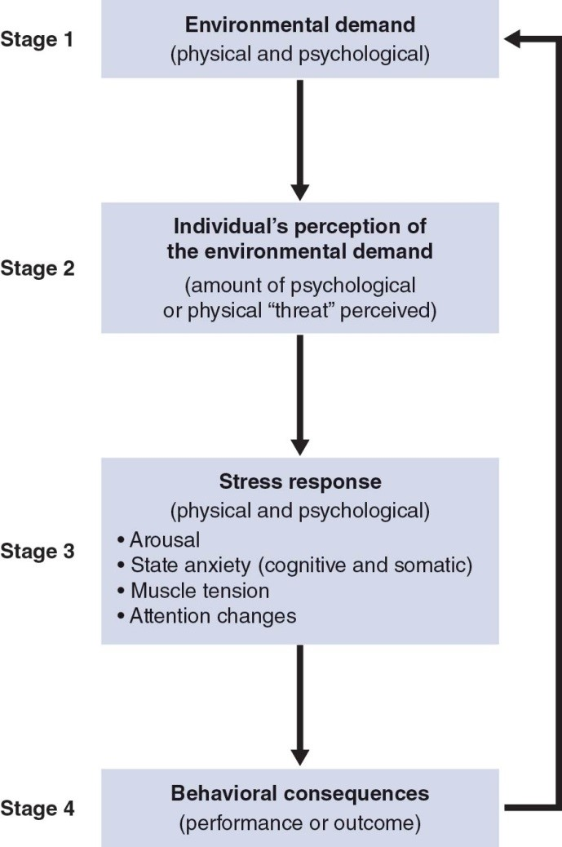
- Choking: a dramatic decrease in performance based on pressures from either internal or external environment.
  - Negative athletic experience causing psychologically damaging effects.
  - Failure to adapt to changing situation, which can result in failed performance
  - Factors: overthinking, expectations, pressure from coaches, peers or parents, feedback

- Attentional Control Theory (ACT): increased levels of anxiety = impaired levels of attentional control = performance deficits in tasks involving the memory system.

- Choking is caused by thinking of the OUTCOME rather than the PROCESS.

- Those Affected: Individuals in the autonomous and associative phases of learning.

- Overcoming Choking: Improve confidence, increase positivity, focus on the task at hand, create structured mental routine.

- Factors that contribute to Choking:
  - Over-thinking, fears, expectations, outside pressures from coaches/parents, type of feedback provided.

- Physiological responses to Choking:
- Increased HR & BP, shortness of breath, shaking/jitters, release of stress hormone, muscle tension, increased blood glucose level.
  - All factors of ‘performance anxiety’.
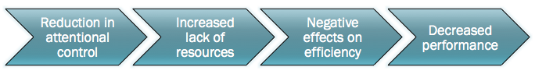
- Recent examples of choking in sports:
- Yu Darvish, 2017 MLB World Series
- Golden State Warriors, 2016 NBA Finals

- Choking is preventable...but sometimes it happens when stakes are high.

